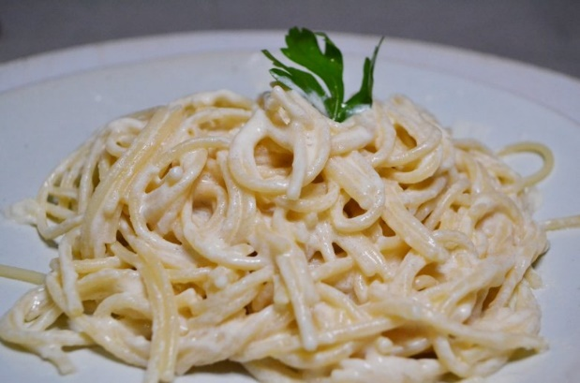
Alfredo Sauce
Prep time 5 min Cook time 15 min
8 Servings

Ingredients
6 oz cream cheese
1 stick of butter
1 quart of heavy cream
8 oz grated parmesan cheese
½ tsp garlic powder
½ tsp minced garlic
1 tsp Italian seasoning

Directions
1. Melt butter and cream cheese in a saucepan over medium heat until completely smooth.
2. Add whipping cream and turn the heat to medium-high. Whisk together until smooth and slightly bubbly.
3. Add parmesan cheese to taste. Stir in garlic powder, minced garlic and Italian season.

Notes
Sauce will thicken slightly upon standing.

